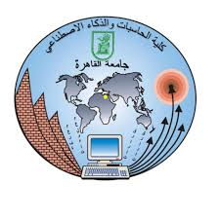**Faculty of Computers and Artificial Intelligence**

**Cairo University**

**Data Warehousing**

**TA. Alaa Adel.**

|  |  |  |
| --- | --- | --- |
| No. | Student Name | ID |
|  | **Rawan Mostafa** | **20200183** |
|  | **Nour Ayman** | **20200604** |
|  | **Mostafa Mahmoud Mohamed** | **20200749** |
|  | **Sara Mahmoud Mohamed** | **20200734** |
|  | **Alaa Eldin Ebrahim Ahmed** | **20200330** |

1. Data flow tasks

Data Flow of create medications fact table

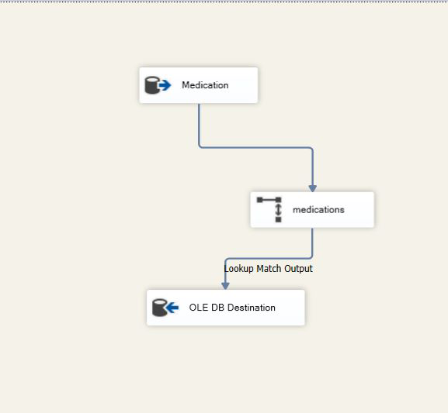

Data flow of create encounter fact table

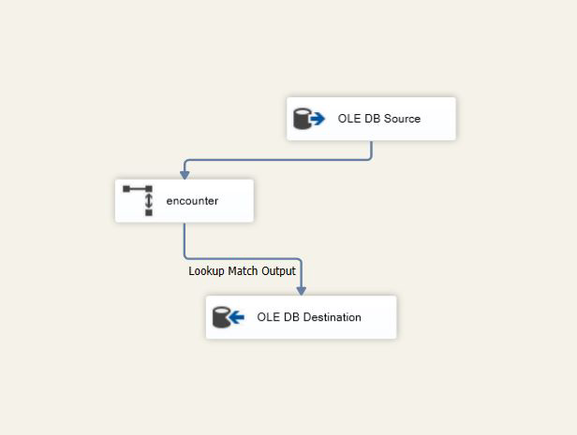

Data Flow of create procedures fact table

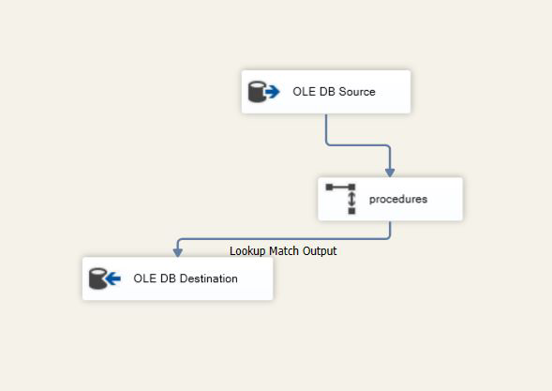

1. Queries on fact tables

